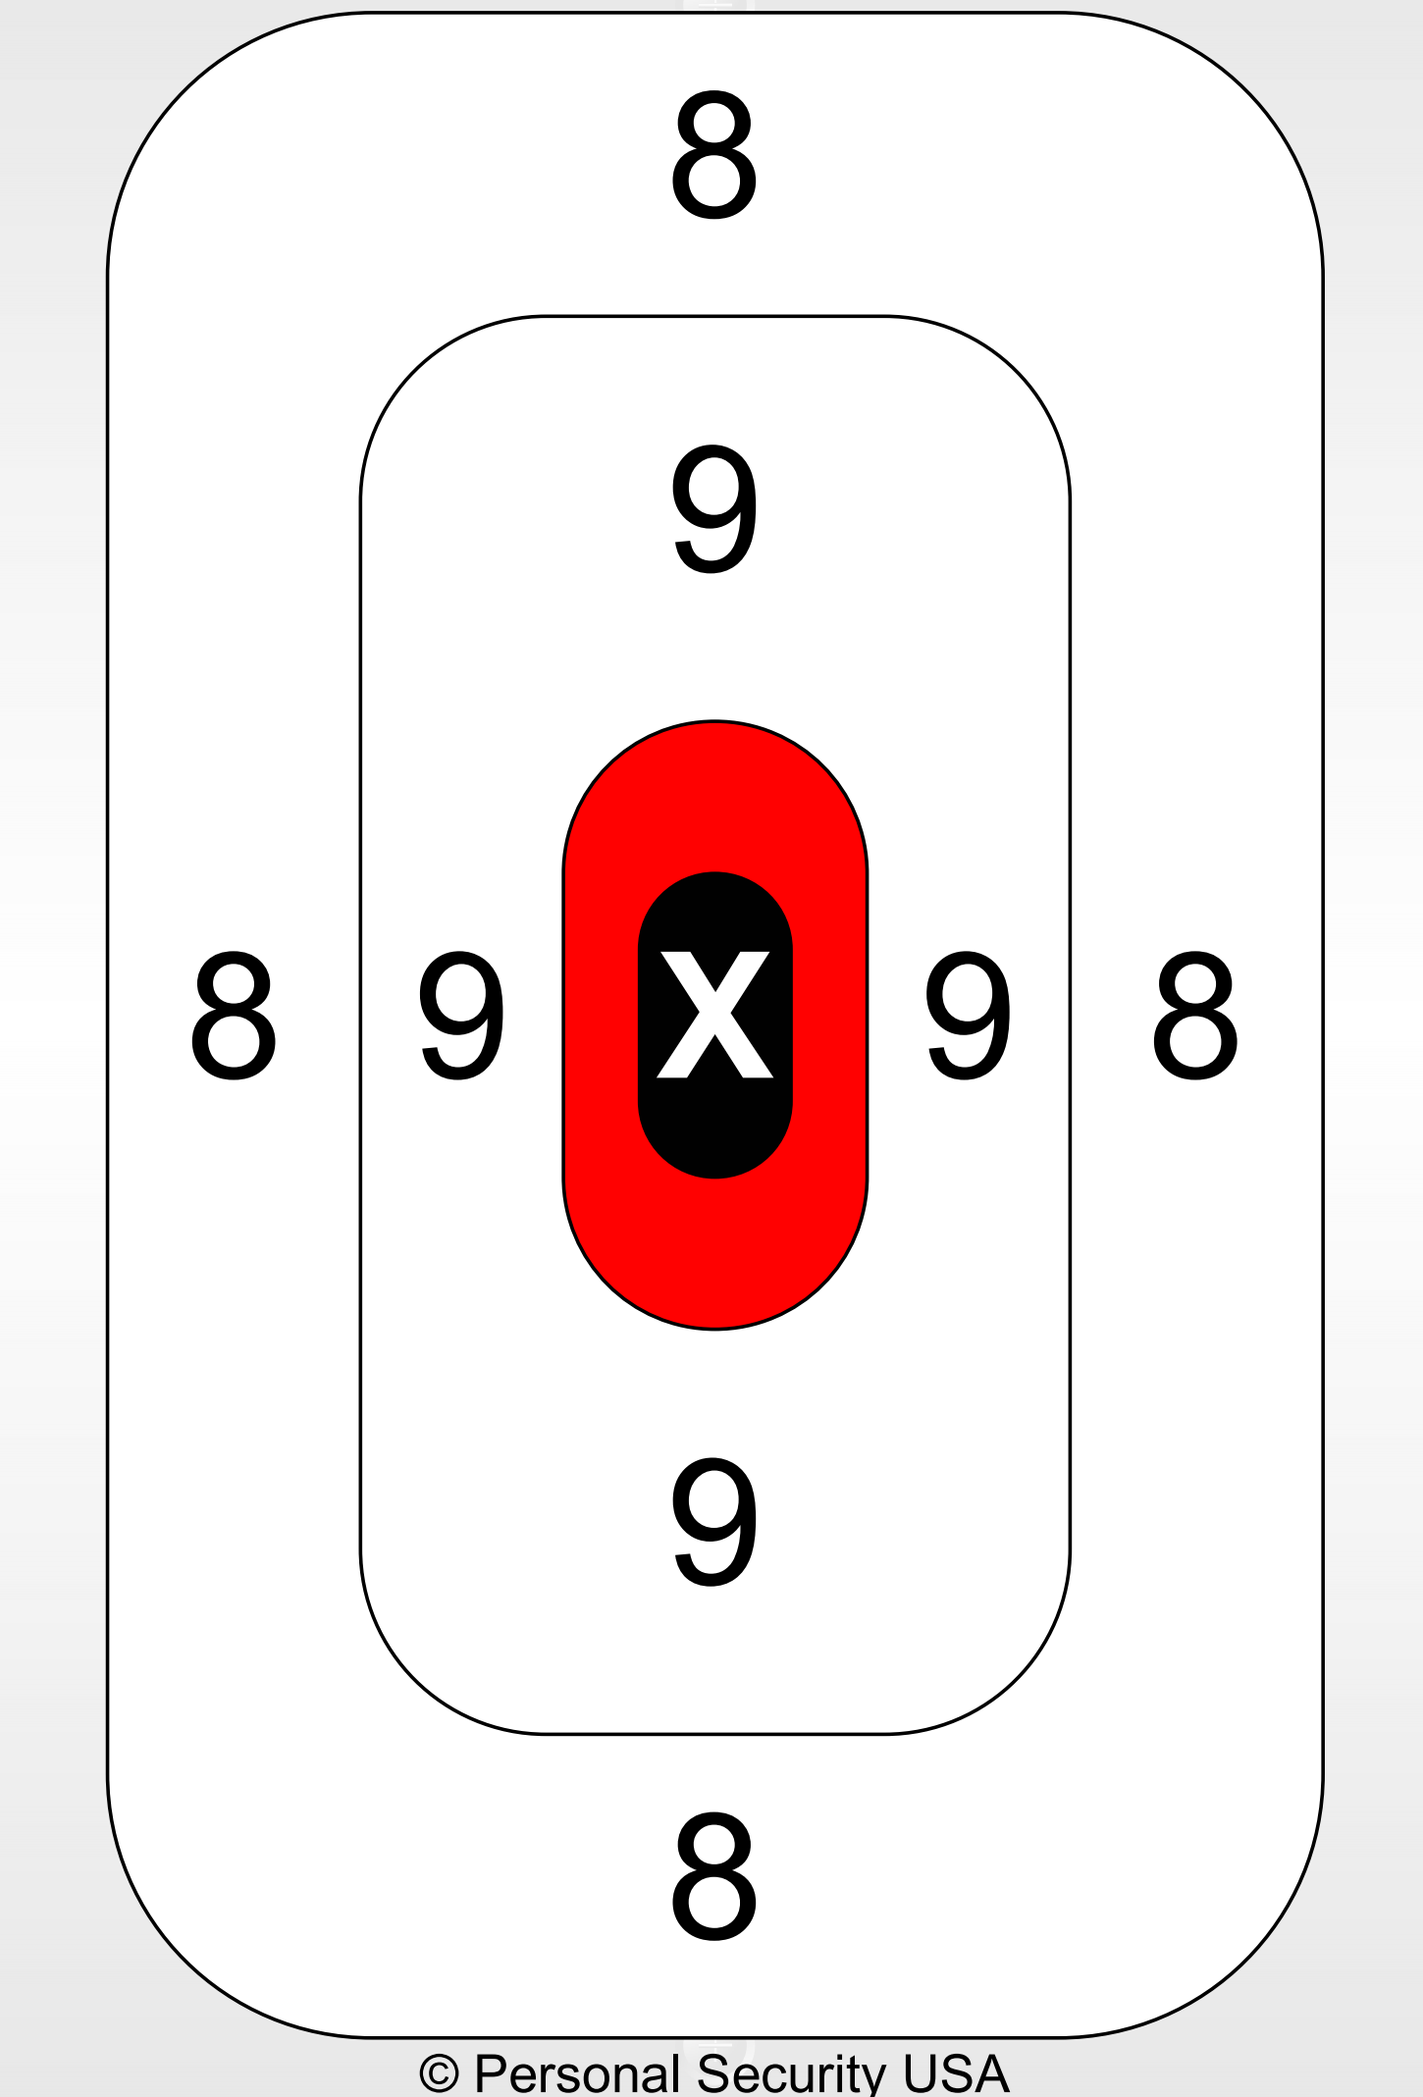
ACCURACY PISTOL LEAGUE TARGET THREE (3) Full Name: _____________________________
Pistol All – 16.5 Yards (50 feet) Week Match #: _______ Target String #: ___________

